**GITHUB 1: Getting Started**

GITHUB is a file management system that does the following:

1. Keeps your files in the cloud
2. Easily maintain different versions of your code
3. Great for collaboration, keeps track of everyone’ changes!

We will Github to manage the lecture files.

**Step 0: Basic Setup (only do once)**

1. Open a Github account by going to “github.com”. Try to register with your Emory email since you sometimes get student benefits. Be careful selecting your username, this will be visible to the public.

1. Download Github Desktop from:

<https://desktop.github.com/>

**Step 1: Adding “QTM 151 Lecture Notes” to your account (only do once)**

1. Sign-in to “Github.com” using the account detail
2. Go the website of the repository with the lecture notes:

<https://github.com/alejandrosanchezbecerra/qtm151spring2023>

1. Click on the “Fork Button” in the top-right corner

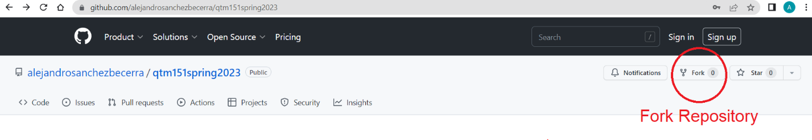

1. You will be asked to make your own copy of the lecture notes. You can add any name you like. For now we will use the name “emoryqtm151”

**Step 2: Downloading Lectures to your Computer (only do once)**

1. Open Github Dekstop
2. Click on the “File” tab. Select the option “Clone repository”. Choose the repository you want to clone. In this case it would be

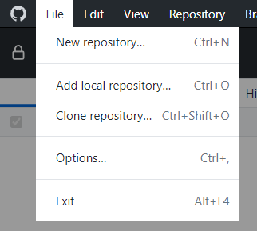

* The local path is where you want to store this on the computer
* Avoid storing in a subfolder of another file sharing system, e.g. “One-Drive” or “Dropbox”. Sometimes this can cause issues.

1. In the next page, SELECT the option “To contribute to the parent project”.
   1. This option allows you to keep updating your lecture notes from the instructor’s repository.
   2. The other option creates a local-copy that has no links to the original. If you accidentally choose this option, you won’t be able to see any changes. To reverse: (a) remove the repository on your computer (by right-clicking on the repository on Github dekstop), (b) manually delete the directory, (c) go back to Step 3.

You’re done! You should have access to the lecture notes.

**This notes will be updated constantly! Check the next manual on how to update a repository.**